

**Volunteer Newsletter Summer 2025**

The past few months at St Mary’s have been packed with a wide range of activities.

**Bug Hotel and School visits -** Our new Buggingham Palace bug hotel has been partially filled by pupils visiting from schools during late June and early July. Tregoze school year one visited for a mainly RE visit while Oliver Tomkins school came for history / RE. It is good to see the church being used in this way and the genuine interest and enthusiasm shown by the children.

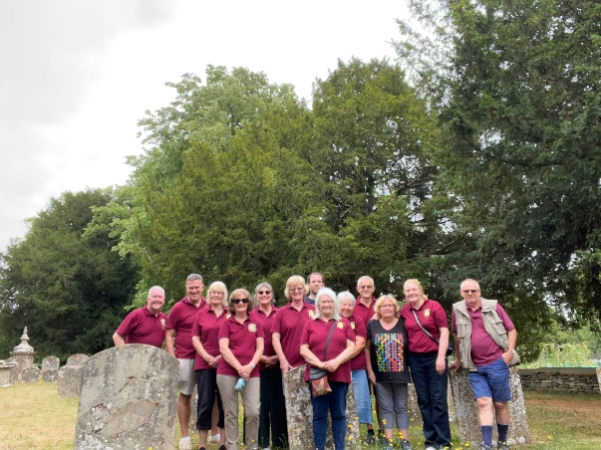Buggingham Palace will be completed over the holiday period by visiting children.

On **Saturday 5th July the bellringing team** enjoyed a summer outing to ring bells in four local churches gaining valuable ringing and bell handling experience. This was followed by an evening BBQ and pudding party – an enjoyable time was had by all.

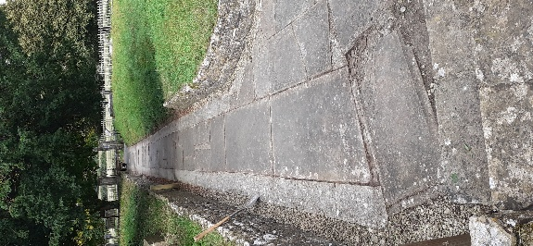Several **gardening days** have been held and training given to use the new lawnmower and strimmer. Sue, our advisor has sent through a very useful follow-up report with achievements and ongoing suggestions and guidance. A huge thanks to all who have helped with this.

**Polyptych and William Larkin painting** – this was open for visitors to view on Friday, Saturday and Sunday 25th-27th July. Around 160+ visitors with accompanying dogs, babies and children came to visit the church during the weekend, including many international visitors. The **bell tower** was also open on Sunday afternoon 27th July with visitors climbing the winding stairs to view and ring our historic bells and have a brief introduction to the art of campanology.

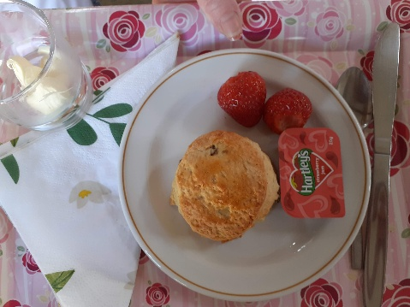**Strawberry Teas** – these delicious treats continue to be popular on Sunday afternoons throughout the summer. Do come and try one (or more) and bring your family and friends. These continue until Sunday 21st September. Thanks to Pat, Pauline and all the team who bake, set-up and serve.

**Heritage weekends** – the church will have additional opening and probably quite a few additional visitors during 12th-14th and 19th-21st September. Thank you to everyone for additional shifts etc during this time.

We are shocked and saddened to lose our dear friend and fellow volunteer **Bob Nicholas** so suddenly. Bob was a really down-to-earth, caring person who brought much to St Mary’s, the wider community and all those he came in contact with. Our thoughts, prayers and sympathies go to his lovely wife Linda and the wider family. He will be missed by all those who knew him.

**Date for your diary** – Volunteers will be invited to attend and participate in Carols and Cream Tea at St Mary’s on Tuesday 9th December at 4pm. All volunteers welcome – more details to follow.

Ann Hutchinson [volunteer@stmaryslydiardtregoze.org.uk](mailto:volunteer@stmaryslydiardtregoze.org.uk)